# **Suspension System**

## **Physical setup**

Designing an automotive suspension system is an interesting and challenging control problem. When the suspension system is designed, a 1/4 model (one of the four wheels) is used to simplify the problem to a 1-D multiple spring-damper system. A diagram of this system is shown below.

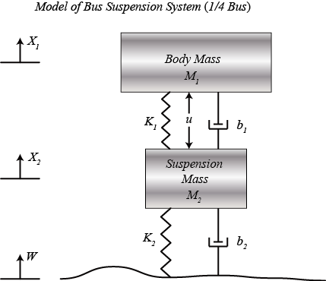

The system parameters are as follows.

(m1) body mass 2500 kg

(m2) suspension mass 320 kg

(k1) spring constant of suspension system 80,000 N/m

(k2) spring constant of wheel and tire 500,000 N/m

(b1) damping constant of suspension system 350 N.s/m

(b2) damping constant of wheel and tire 15,020 N.s/m

(u) control force = force from the controller we are going to design

## **Building the Model**

This system will be modeled by summing the forces acting on both masses (body and suspension) and integrating the accelerations of each mass twice to give velocities and positions. Newton's law will be applied to each mass. Open Simulink and open a new model window. First, we will model the integrals of the accelerations of the masses.

(1)$$
\int\int\frac{d^2x_1}{dt^2}\ dt = \int\frac{dx_1}{dt}\ dt = x_1
$$

(2)$$
\int\int\frac{d^2x_2}{dt^2}\ dt = \int\frac{dx_2}{dt}\ dt = x_2
$$

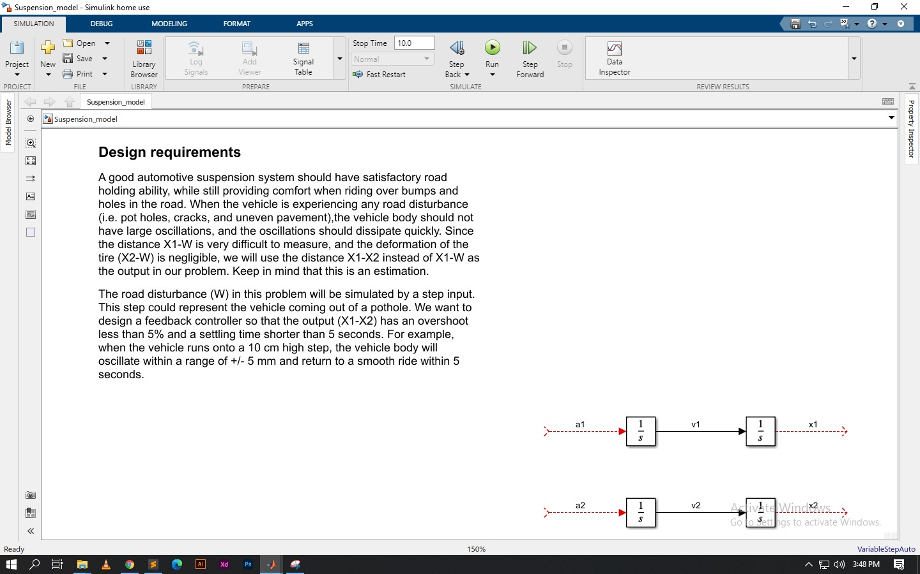

we will start to model Newton's law. Newton's law for each of these masses can be expressed as:

(3)$$
\frac{1}{M_1} \Sigma_1 F = \frac{d^2 x_1}{dt^2}
$$

(4)$$
\frac{1}{M_2} \Sigma_2 F = \frac{d^2 x_2}{dt^2}
$$

Then, we will add in the forces acting on each mass. First, we will add in the force from Spring 1. This force is equal to a constant, k1 times the difference X1-X2.

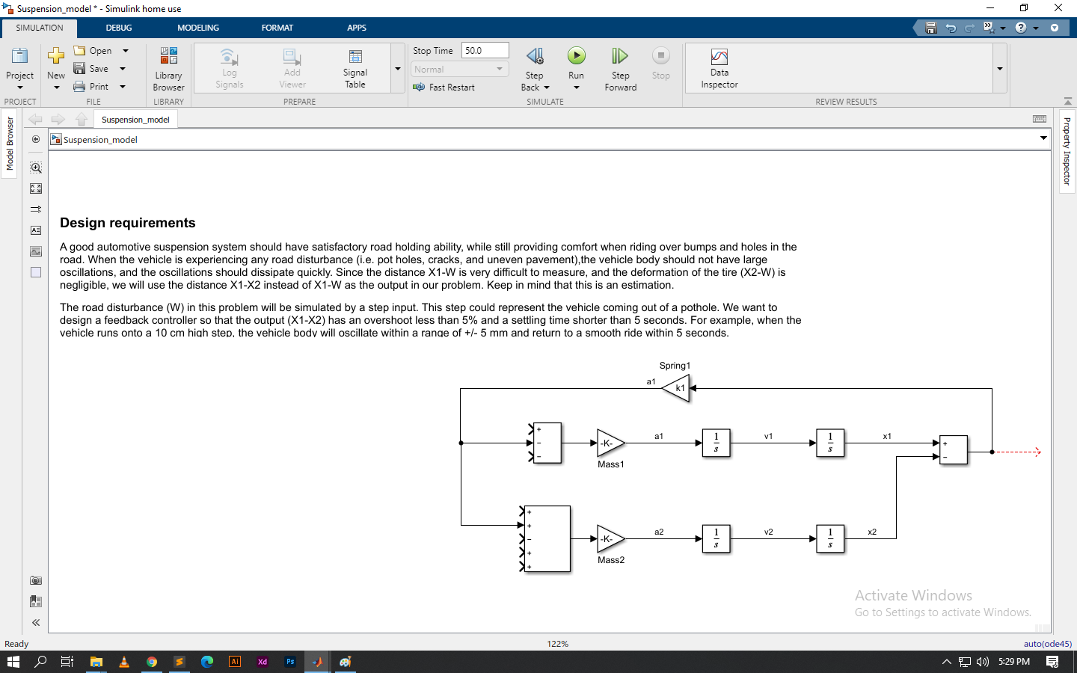

Then, we will add in the force from Damper 1. This force is equal to b1 times V1-V2.

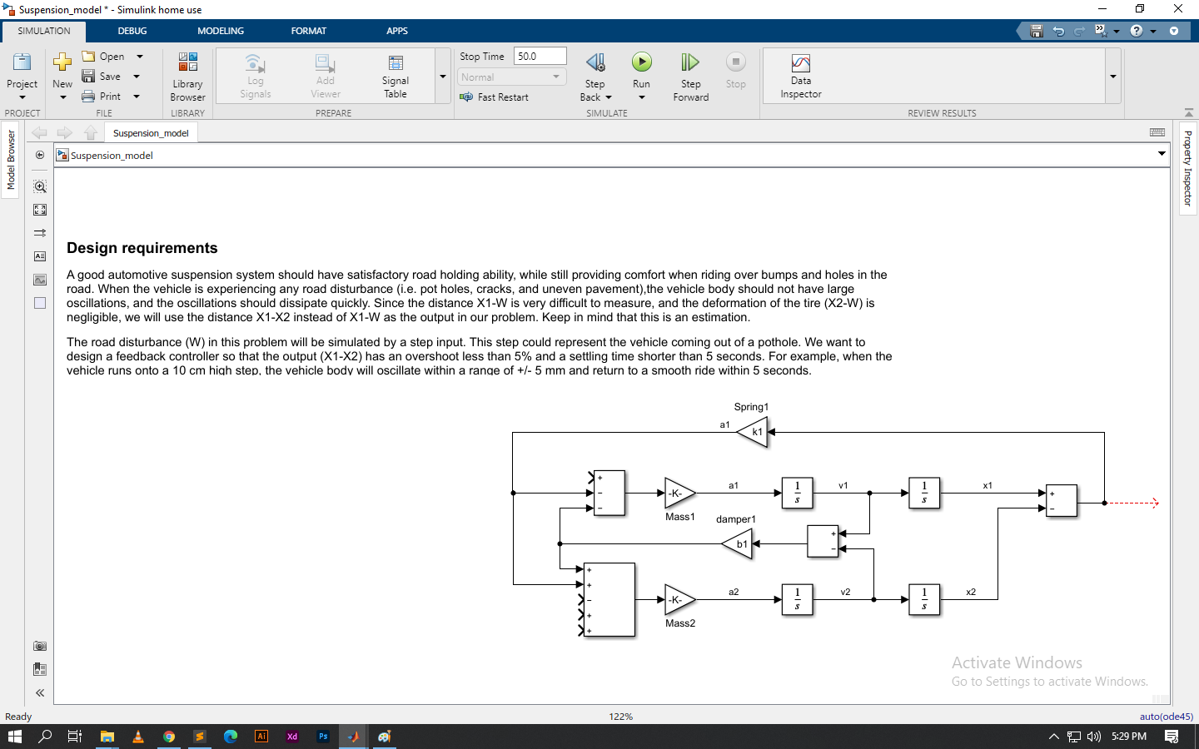

we will add in the force from Spring 2. This force acts only on Mass 2, but depends on the ground profile, W. Spring 2's force is equal to X2-W.

.

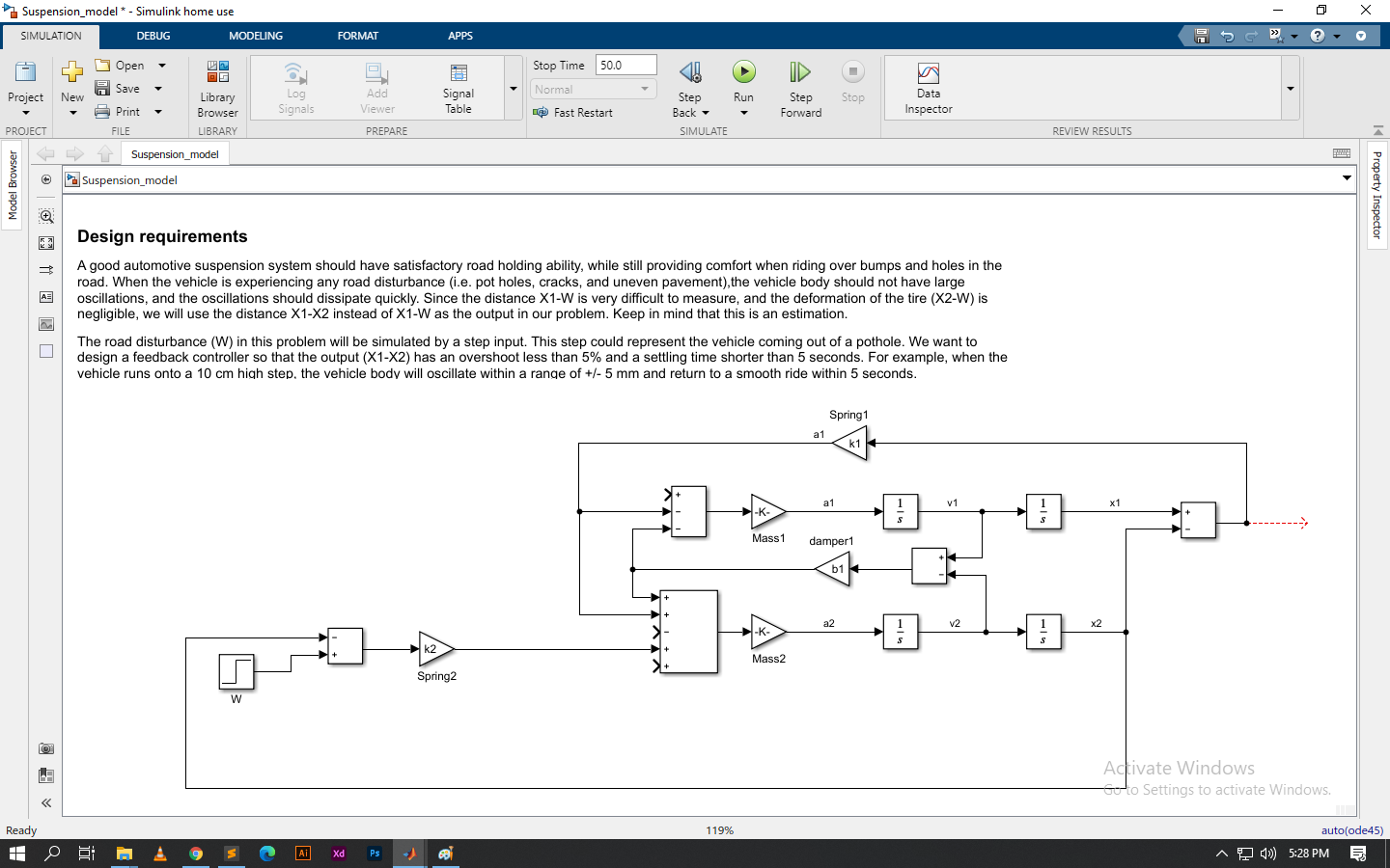

we will add in the force from Damper 2. This force is equal to b2 times V2-d/dt(W). Since there is no existing signal representing the derivative of W we will need to generate this signal.

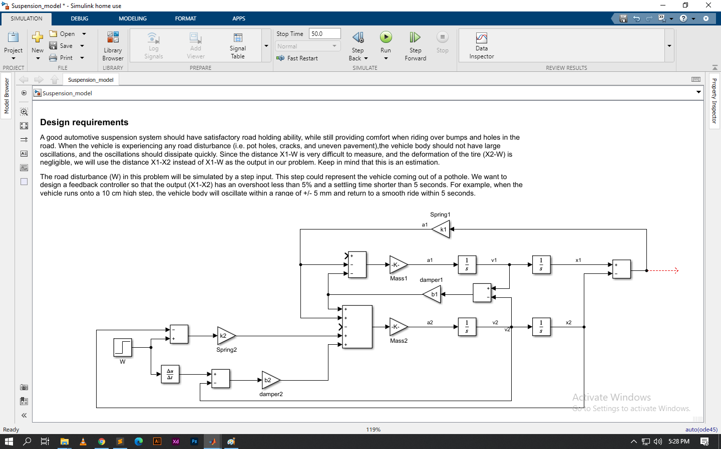

The last force is the input U acting between the two masses.

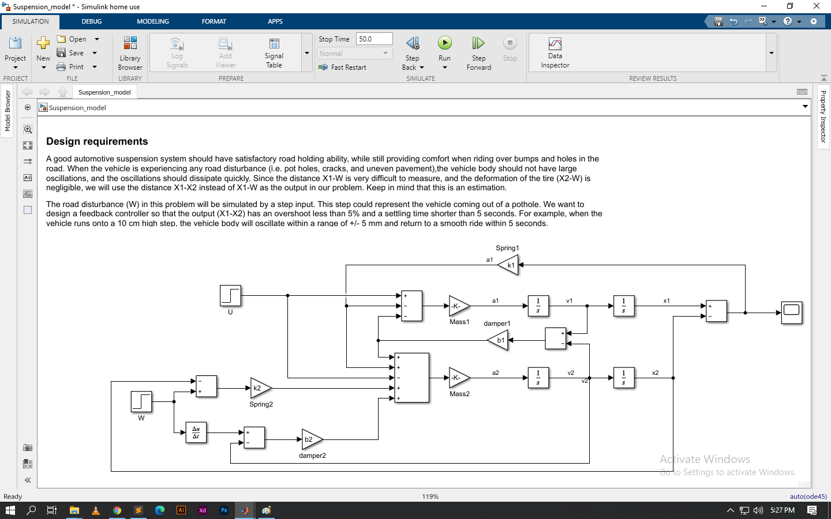

Created sub system

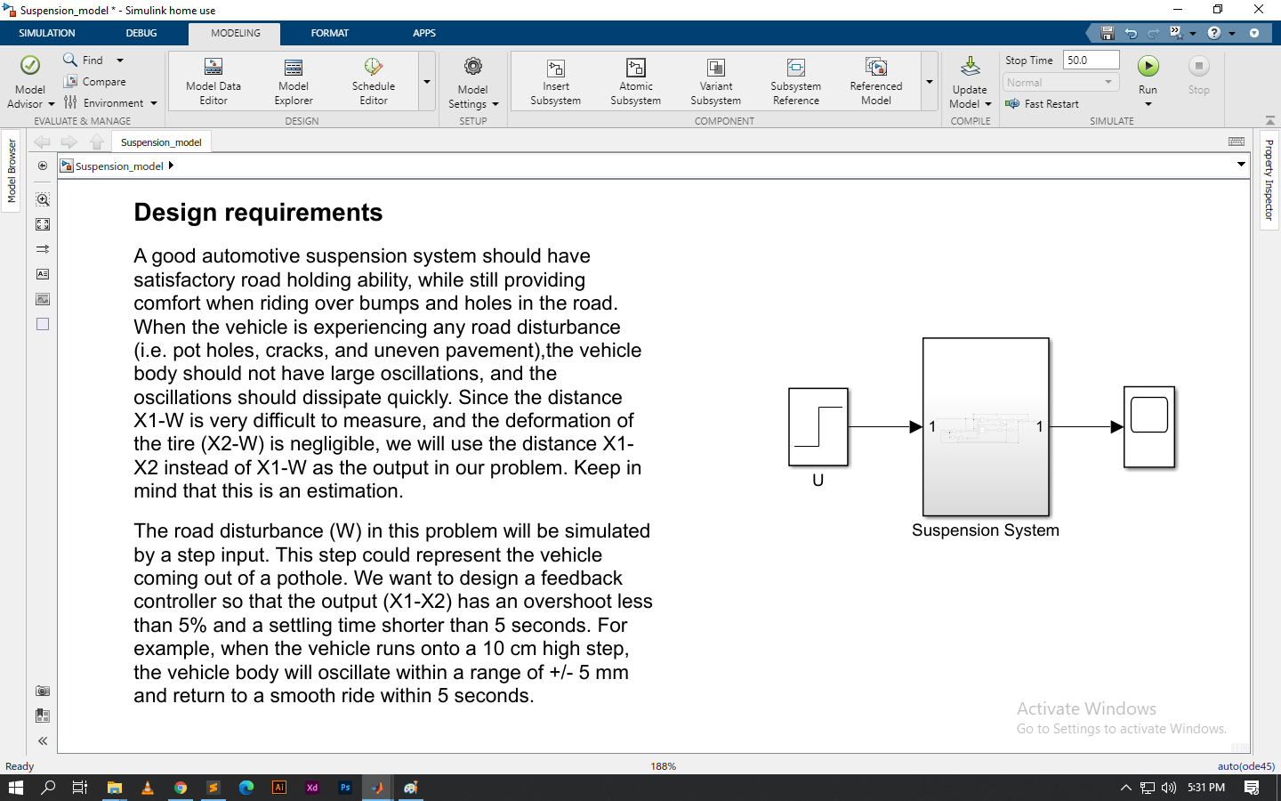

Output

